Playwriting Productions, Readings & Awards

2026

Dante in Love
Showcase (10/15) Third Place
Alpha Psi Omega’s “Play in a Night”
Flagler College, St. Augustine, Fla.



The Kids’ Table
Production (9/17)
The Village Playbox
Act 1 Scene 1 One Act Festival
The First Presbyterian Church, Haddon Heights, N.J.
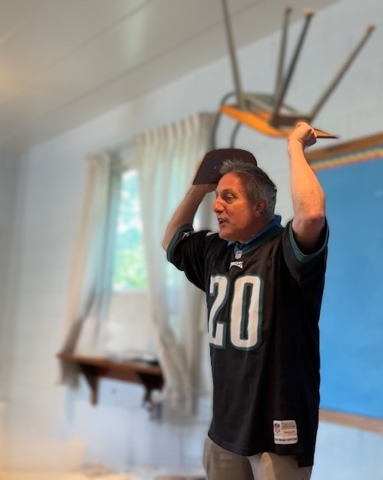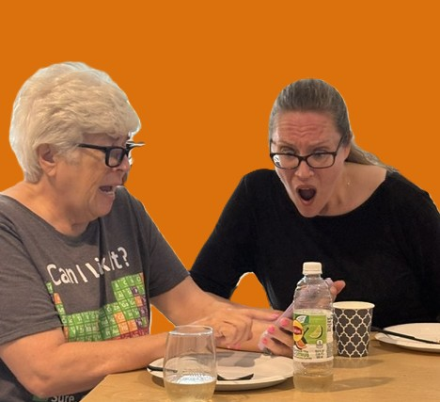
(Left) Doug Cohen as Skip. (Right) Jenni Maienza (left) as Lisa and Bonnie Renner-Ohnishi
as Cindy. Not pictured, Steve Allen as Tom, and Anita Rowland, director
Primary Care
Production (8/29) – Winner – Best Play
Ritz Theatre Company One-Act Play Festival
915 White Horse Pike, Haddon Township, N.J
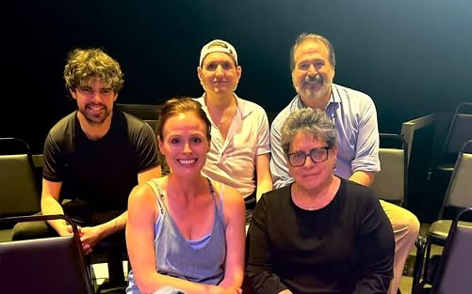
Top row from left, John Hager, Connor Twigg (director) and David Nikolas.
Bottom row, MacKenzie Ryann and Rosemary Parrillo.

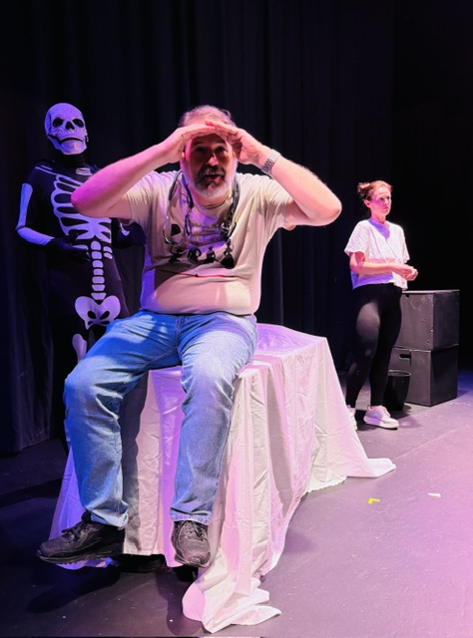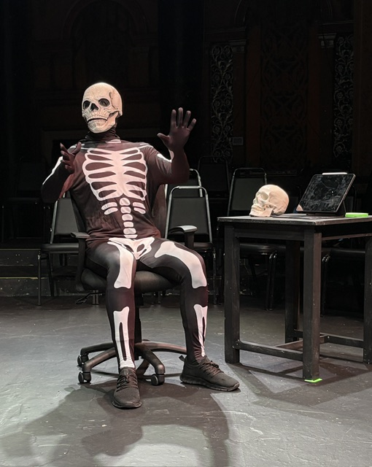
(Left to right), John Hager, David Nikolas and MacKenzie Ryann. And John Hager as the
articulated skull, Harry.
Boomerang & The Best One
Production (7/24, 25, 26)
Kaleidoscope Kabaret
The Theatre Project
DMK Theatre, Union Arts Center, Union, N.J.

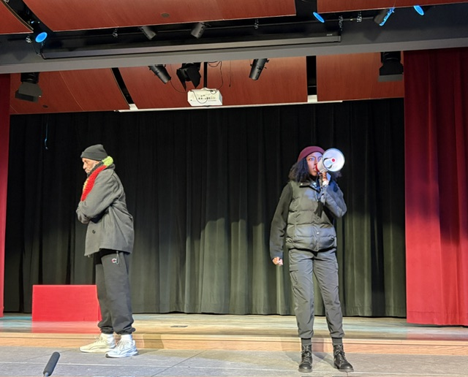
Andre DeSandies (left) and Tatum Thompson in "Boomerang."

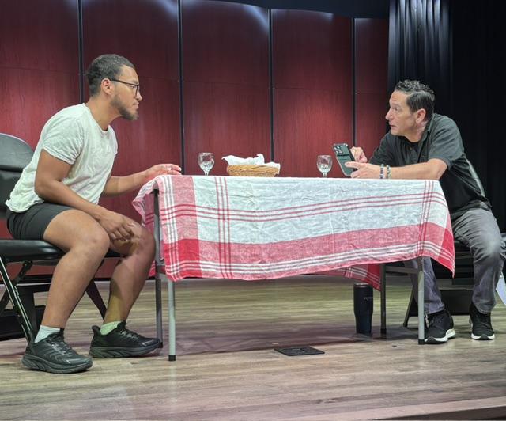
Nicholias Flores (left) and Dan Vissers in "The Best One."

The Kids’ Table
Production (7/24, 25, 26) (Second Place)
One Act Jamboree
StageWorks Theatre, Pompton Lakes, N.J.

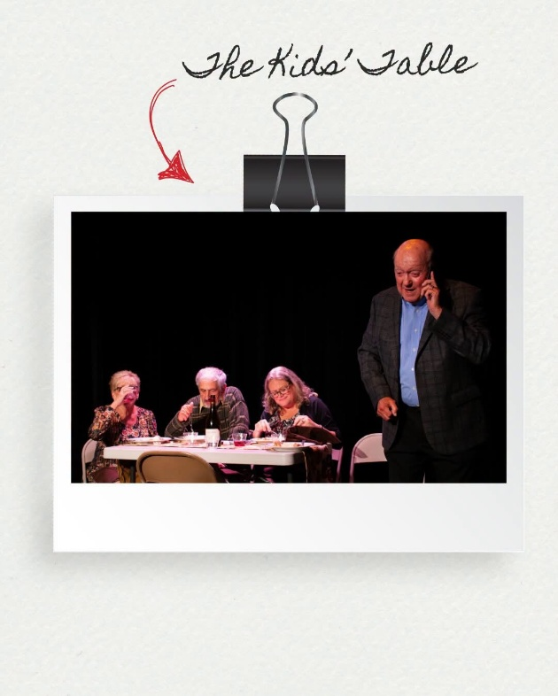

From left, Brooke Kaye, Joe DeSpirito, Maureen Lambrix and Tom Lambrix, in "The Kids' Table.

The Best One
Staged Reading (5/14)
Festival of Short Plays
National Playwrights Symposium
Cape May Stage, Cape May, N.J.

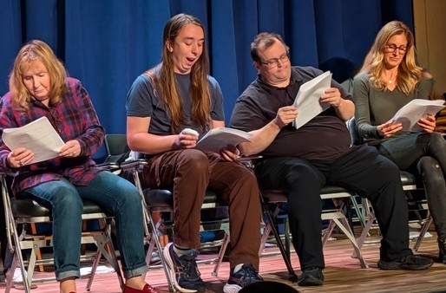

Three By One
Staged Readings (2-21)
Theatre Project, Cranford, N.J.
Sheila and the DMV * Our Man in China * The Kids’ Table
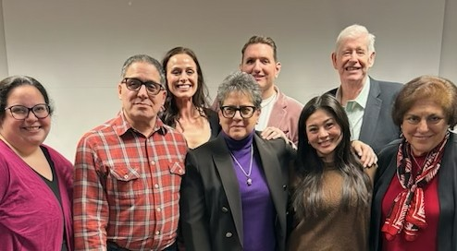
Bottom row, from left: Jillian Starr Renbjor, Gary Martins, Julia Way and Anita Rowland. Top row: MacKenzie Ryann, Connor Twigg and Paul Murphy.

2025
The Waiting Room
Production (8/24) – Winner – Best Play
Ritz Theatre Company One-Act Play Festival
915 White Horse Pike, Haddon Township, N.J
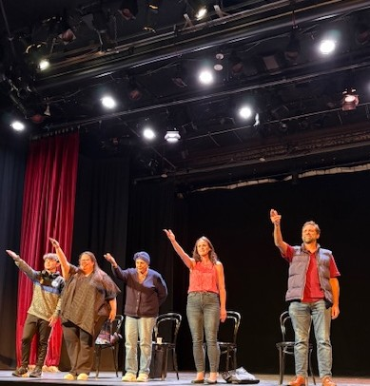

Payday
Production (8/1,2,3)
Kaleidoscope Kabaret
The Theatre Project, Oakes Center, Summit, N.J.
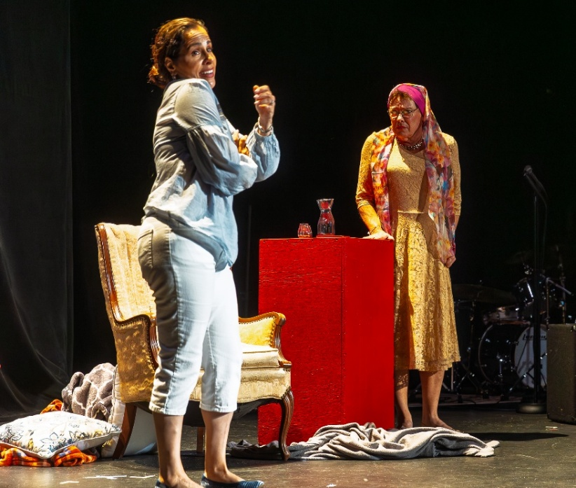

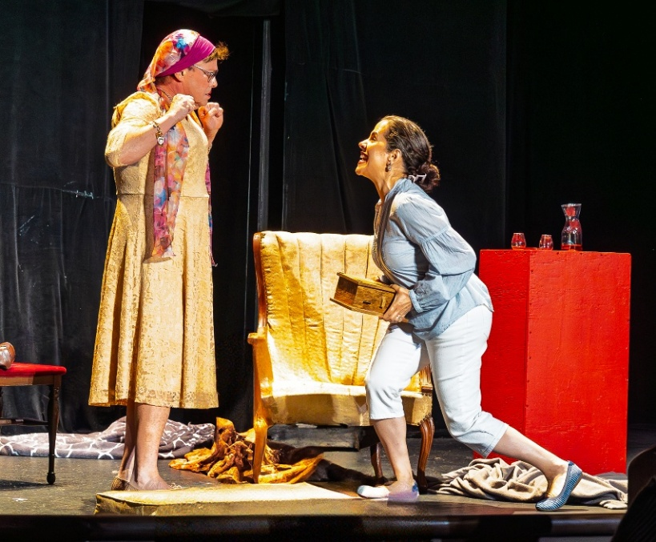

Sandra Toll (Fran) and Harry Patrick Christian (Martha) nearly come to blows when the numbers don’t add up in “Payday,” directed by Will Budnikov. (Photos/John Posada)
Spaghetti Western
Staged Reading (3/15))
Theatre Project, Cranford, N.J.
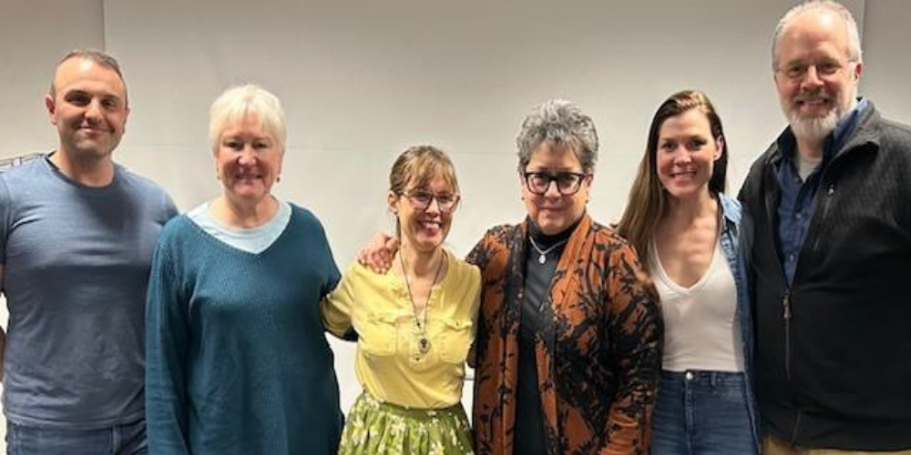
Will Budnikov (Surveyor/Director), Angela Della Ventura (Josie), Lisa Ferraro (Camila), Jeanie Bartel (Olivia), and David Tillistrand (Rocco).

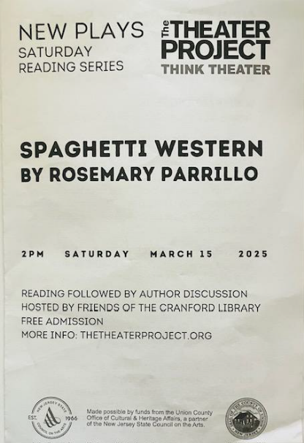
2024
The Nature of Stars
Staged Reading (11/16)
Theatre Project, Cranford, N.J.
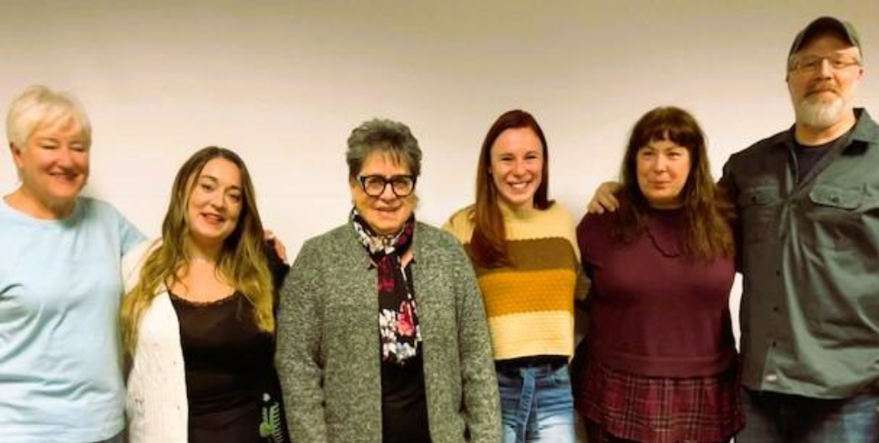
Angela Della Venura (Marcia), Emily Bonaria (Naomi), Rosemary Parrillo, Samantha Simone (Mia), Lynn Marie Macy (director) and David Tillistrand (Warren).

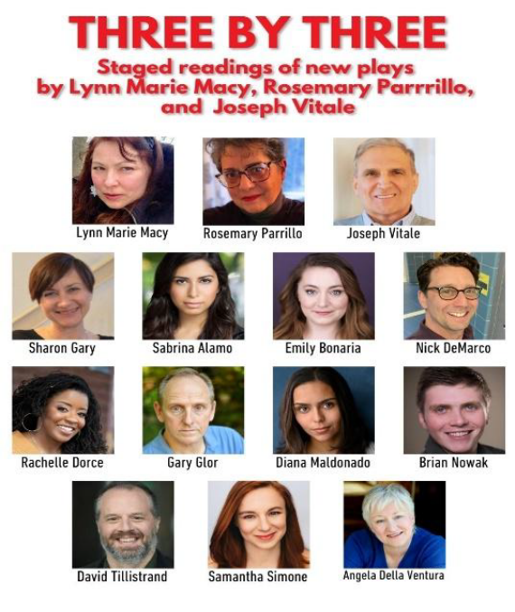
Spaghetti Western
Staged Reading (10/21)
Waterfront South Theatre, Camden, N.J.
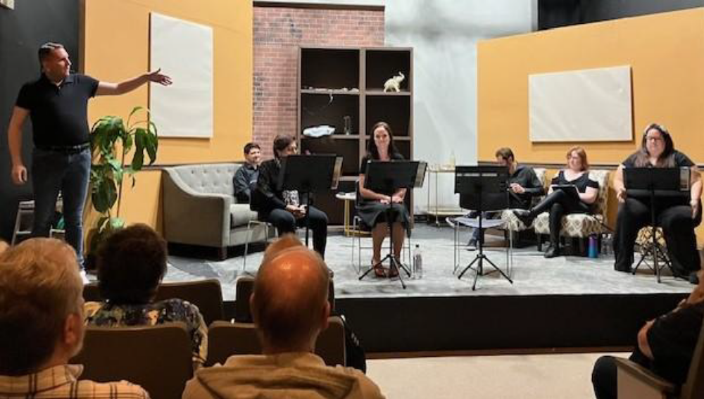
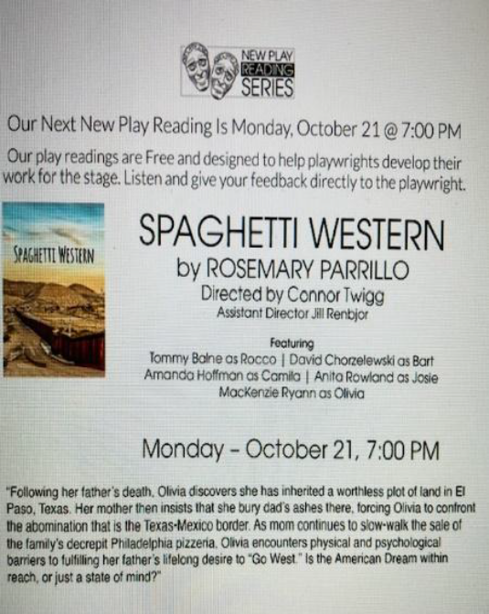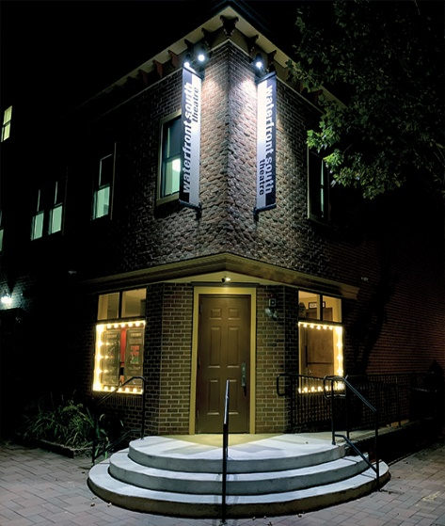
The Nature of Stars
Production (9/7)
Newmarket International Festival of One-Acts
The Old Town Hall, Newmarket, Ontario, Canada
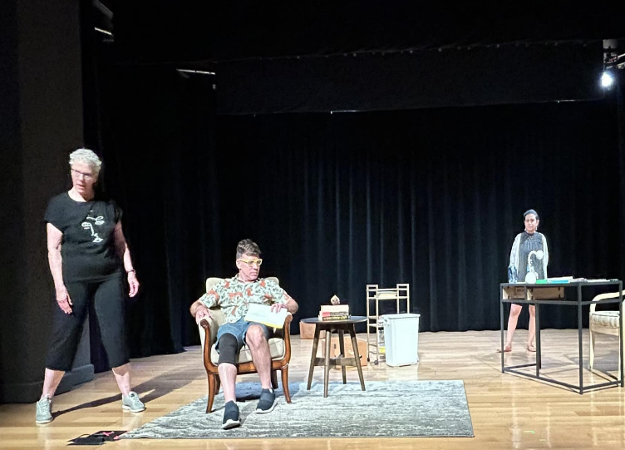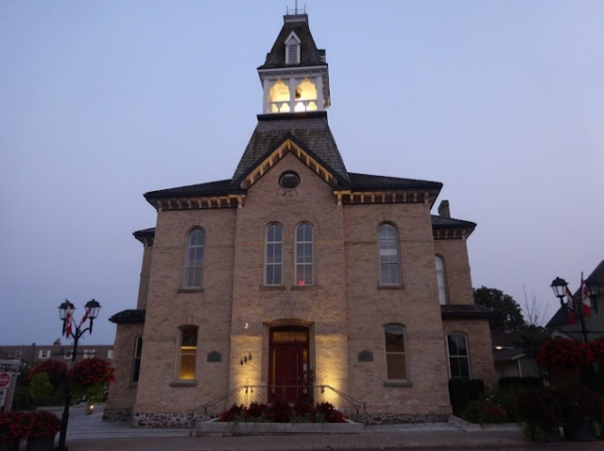
Laurie Laing and Tim Gerstein (left) and Aliah Sakr at a rehearsal for “The Nature of Stars,” directed by Gerri Sefi, at the Newmarket International Festival of on Act Plays.

Sheila and the DMV
Production (6/28)
Ritz Theatre Company One-Act Play Festival
915 White Horse Pike, Haddon Township, N.J
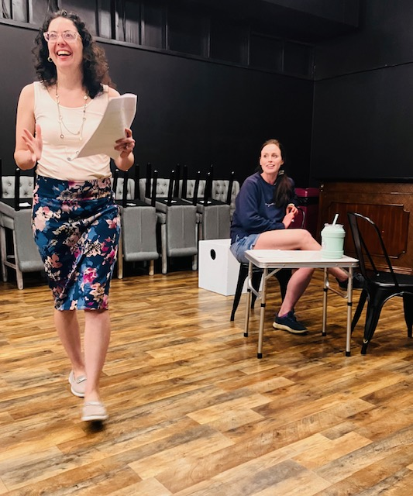 
Megan Baine, left, and Mackenzie Smith in rehearsal for “Sheila and the DMV.”
On the Road to Tikrit
Podcast (5/28)
Sell Yourself Short
Curtain and Mic Productions


The Invisible Cosmo
Staged Reading (5/16)
National Playwrights Symposium Short Play Reading
Cape May Stage, 405 Lafayette St., Cape May
 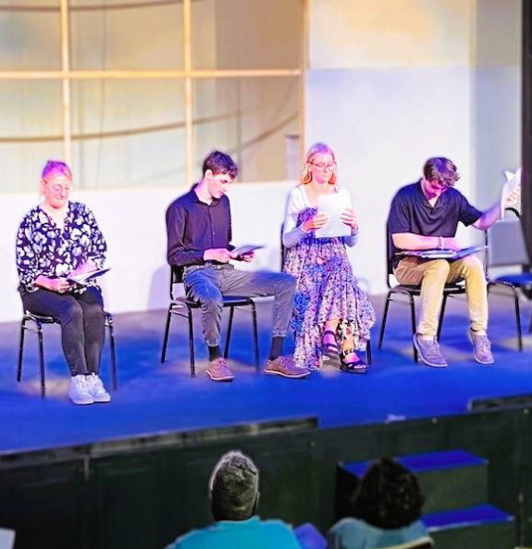
Silver Alert
Staged Reading (5/15)
National Playwrights Symposium
Cape May Stage, 405 Lafayette St., Cape May
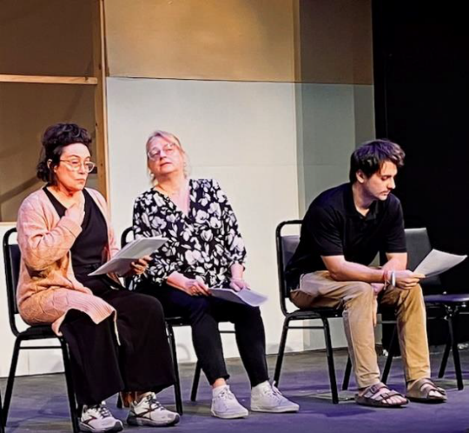

Walking the Dog After Midnight
Finalist (5/4)
Schreiber Shorts Festival, New York
Cent’Anni
Production (3/8)
Festival of One-Acts Strand Theatre, Hudson Falls, N.Y.
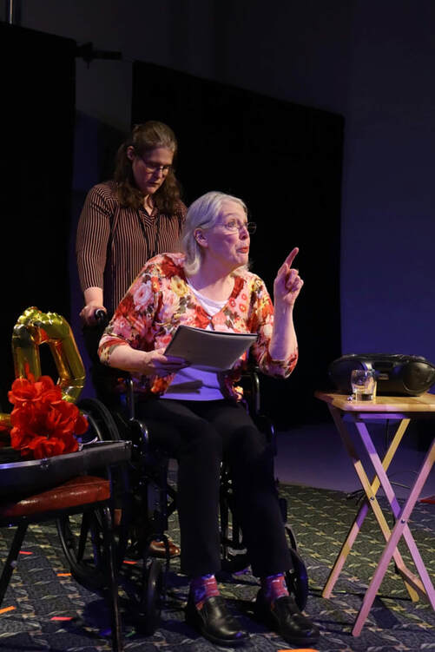
The Nature of Stars
Finalist
Tennessee Williams One-Act Festival, New Orleans, La.


On the Road to Tikrit
Production (1/19 to 2/18)
8 Tens @ 8 Festival at Actors' Theatre
Actors Theatre of Santa Cruz County / Santa Cruz, California
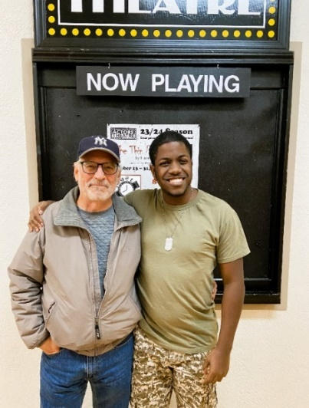 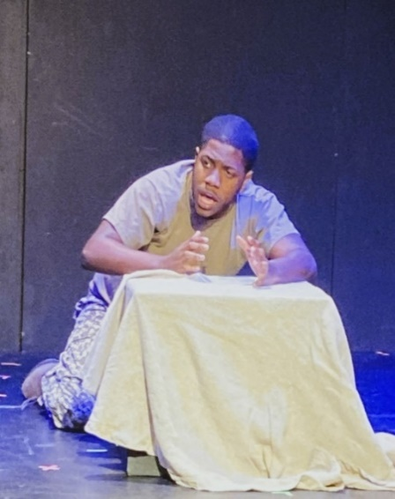
(Left) Steve Capasso, director, with John Denham Bennett outside Actors Theatre in Santa Cruz, Ca. (Right) John Denham Bennett in a scene from On the Road to Tikrit.
2023
Bella Vista
Semifinalist
Off Page Film Festival, Philadelphia, Pa.

Mountain of Things & Ascension Day
Reading
National Playwrights Symposium
Cape May Stage / Cape May, New Jersey
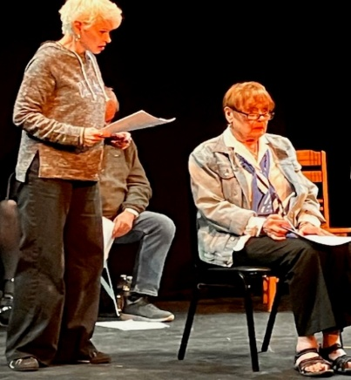
Deirdre Brennan (left) and Marlena Lustik in a scene from Mountain of Things.
The Waiting Room
Production
Minnesota High School League One-Act Play Competition
Two Harbors, Minnesota
Student cast discusses the play with WTIP Community Radio:
https://wtip.org/high-school-one-act-play-the-waiting-room-open-to-public-on-february-2/
The Waiting Room
Reading
Zoom Reading Series, The Playwrights Group


2022
Grind City
Honorable Mention
New Works of Merit Playwriting Contest, New York, N.Y.
2021
Spaghetti Western
Semifinalist
Meet the Artist Reading Series
Dreamcatcher Repertory Theatre, Summit, N.J.
2020
Lockdown
Zoom performance (6/30)
Meet the Artist Reading Series with Emily Mann
McCarter Theatre, Princeton, N.J.
2019
The Waiting Room
Short List
Gaslight Baker Theatre One-Act Play Contest
Lockhart, Texas
2018
The New Normal Trilogy
Semifinalist pool
Play Penn Conference, Philadelphia, Pa.
Oasis Café
Finalist
Tennessee Williams One-Act Play Contest, New Orleans, La.
2017
The New Normal Trilogy
Semifinalist
The O’Neill Playwrights Conference, Waterford, Ct.

Grind City
First Place
The Dubuque Fine Arts One-Act Play Writing Contest
Dubuque, Iowa
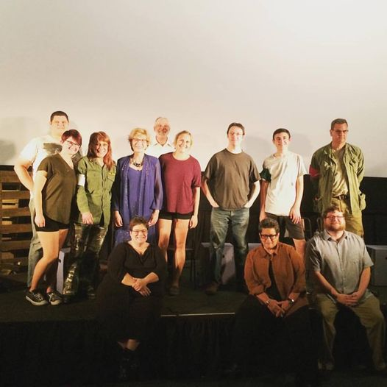
The cast of “Grind City” and other artists at the Dubuque Fine Arts Festival.
Grind City
Finalist
Tennessee Williams One-Act Play Contest, New Orleans, La.
2014
Lou’s 24/7
Top 10
Mindframe Theater in Dubuque, 37th Annual National One-Act Playwriting Contest.
2013
Lou’s 24/7
Finalist
Ethical Society One-Act Play Contest
Rittenhouse Square, Philadelphia, Pa.
2006
Lou’s 24/7
Finalist
New Generation Playwriting Contest
Reverie Productions, New York

2005
Lou’s 24/7
Finalist - Production
The Strawberry One-Act Festival
Riant Theatre, New York, N.Y.
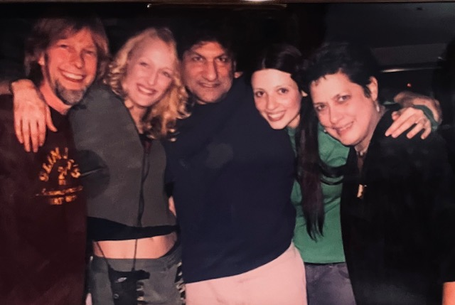
Director Eric Jones , far left, and playwright Rosemary Parrillo, far right, with the cast of “Lou’s 24/7”. Cast, left to right, Shannon Conley (Foxy), Carolyn Morris (Bunny), Michael De Nola (Man).

2004
Lou’s 24/7
Staged Reading
Ocean County College Center for the Arts, Toms River, N.J.
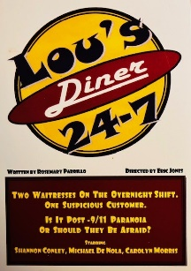
2003
Lou’s 24/7
Finalist
Tennessee Williams One-Act Play Contest, New Orleans, La.
2000
Lou’s 24/7
Production
The Creative Acting Company Short Play Festival, New York, N.Y.
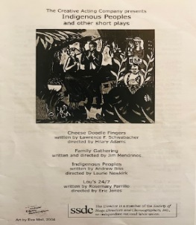
1999
Lou’s 24/7
Staged Reading
New Jersey Playwrights Festival of New Plays
12 Miles West Theatre, Montclair, N.J.
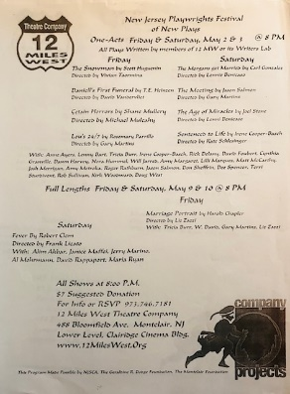

1995
The Waiting Room
Staged Reading
Livewires / New Works by Contemporary New Jersey Writers
Foundation Theatre, Pemberton, N.J.
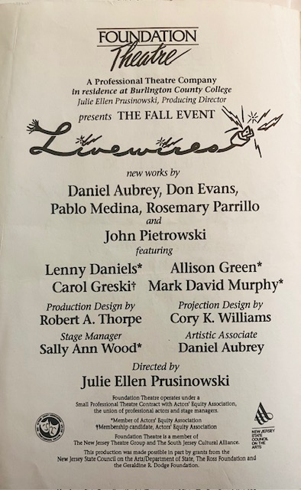

1989
Shelter
Production (5/10,11,12,13)
New African Grove Company / The Africamericas Festival
Freedom Theatre, Philadelphia, Pa
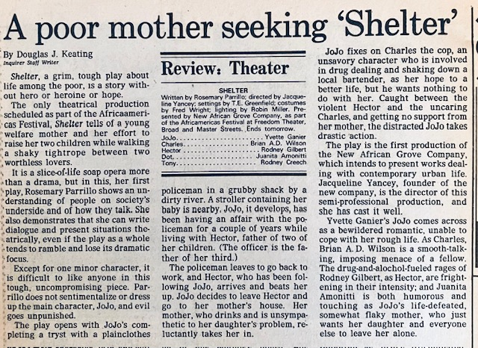 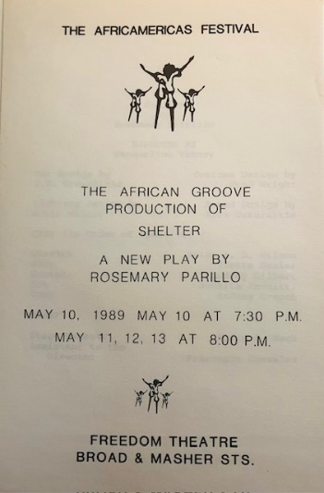
Philadelphia Inquirer review of “Shelter” at Freedom Theater in Philadelphia.
Cent’Ann
Playwriting Showcase
Walnut Street Theatre School, Phila., Pa
Philadelphia, Pa.
Shelter
Staged Reading
Theater Center, Phila., Pa.
1988
Shelter
Playwriting Lab
Walnut Street Theatre School, Phila, Pa.
1985
Madonna’s Stash
Showcase
Walnut Street Theatre School, Phila., Pa

