Playwriting Productions, Readings & Awards
2024
The Nature of Stars / Finalist
Tennessee Willams One-Act Festival
New Orleans, La.

Cent’Anni / Production
Festival of One-Acts
Strand Theatre, Hudson Falls, N.Y.
On the Road to Tikrit / Production
8 Tens @ 8 Festival at Actors' Theatre
Actors Theatre of Santa Cruz County
Santa Cruz, California

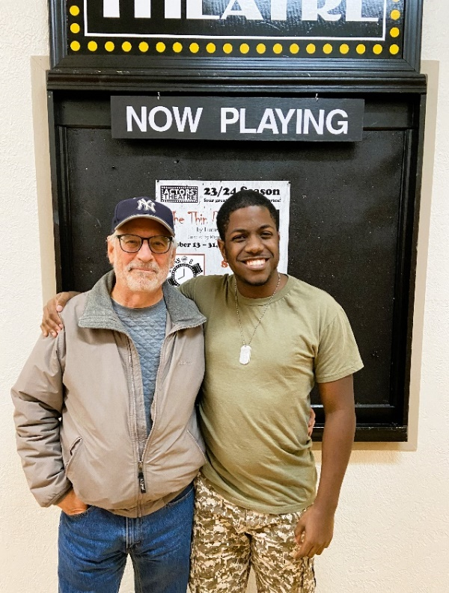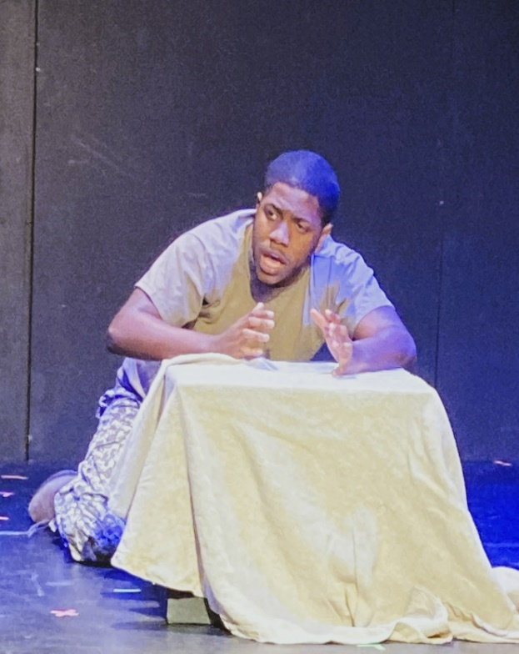
(Left) Steve Capasso, director of On the Road to Tikrit, with John Denham Bennett outside
Actors Theatre in Santa Cruz, Ca. (Right) John Denham Bennett in a scene from On the
Road to Tikrit.
2023
Bella Vista / Semifinalist
Off Page Film Festival
Philadelphia, Pa.
Mountain of Things & Ascension Day / Reading
National Playwrights Symposium
Cape May Stage
Cape May, New Jersey
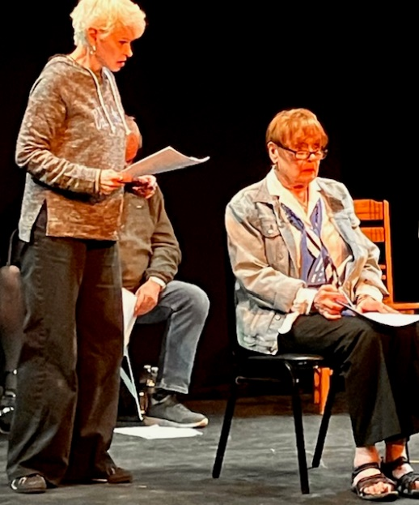
Deirdre Brennan (left) and Marlena Lustik in a scene from
Mountain of Things during the 2023 National Playwrights
Symposium at Cape May Stage.
The Waiting Room / Production
Minnesota High School League One-Act Play Competition
Two Harbors, Minnesota
Student cast discusses the play with WTIP Community Radio:
https://wtip.org/high-school-one-act-play-the-waiting-room-open-to-public-on-february-2/
The Waiting Room / Reading
Zoom Reading Series
The Playwrights Group
2022
Grind City / Honorable Mention
New Works of Merit Playwriting Contest
New York, N.Y.
2021
Spaghetti Western / Semifinalist
Meet the Artist Reading Series
Dreamcatcher Repertory Theatre
Summit, N.J.
2019
The Waiting Room / Short List
Gaslight Baker Theatre One-Act Play Contest
Lockhart, Texas
2018
The New Normal Trilogy / Semifinalist pool
Play Penn Conference
Philadelphia, Pa.
Oasis Café / Finalist
Tennessee Williams One-Act Play Contest
New Orleans, La.
2017
The New Normal Trilogy / Semifinalist
The O’Neill Playwrights Conference
Waterford, Ct.
Grind City / First Place
The Dubuque Fine Arts One-Act Play Writing Contest
Dubuque, Iowa
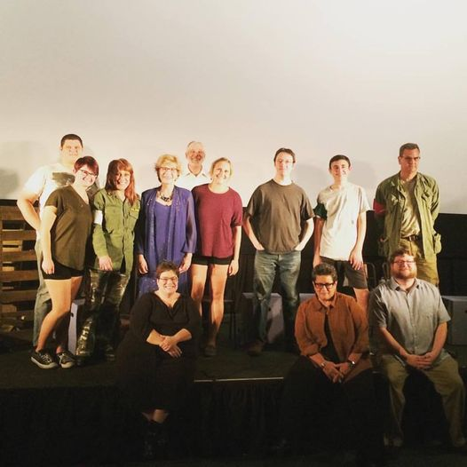
The cast of “Grind City” and other artists at the Dubuque
Fine Arts Festival.
Grind City / Finalist
Tennessee Williams One-Act Play Contest
New Orleans, La.
2013
Lou’s 24/7 / Finalist
Ethical Society One-Act Play Contest
Rittenhouse Square, Philadelphia, Pa.
2005
Lou’s 24/7 / Finalist - Production
The Strawberry One-Act Festival
Riant Theatre, New York, N.Y.
.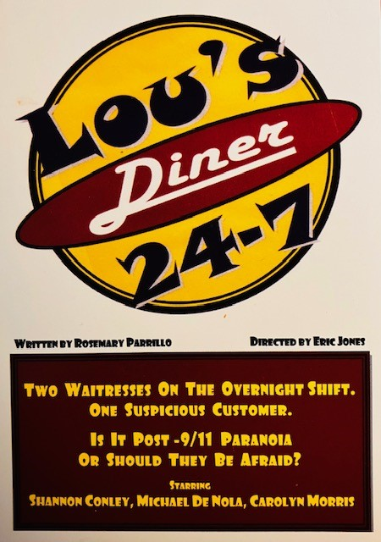
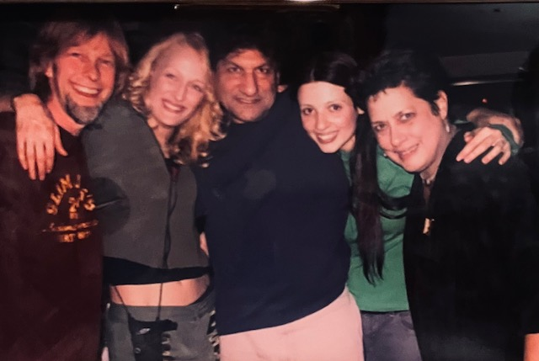
Director Eric Jones , far left, and playwright Rosemary Parrillo, far right, with the cast of
“Lou’s 24/7” at the Strawberry One Act Festival at the Riant Theatre in Manhattan. Cast,
left to right, is Shannon Conley (Foxy), Carolyn Morris (Bunny) and Michael De Nola (Man).
2004
Lou’s 24/7 / Staged Reading
Ocean County College Center for the Arts
Toms River, N.J.
2003
Lou’s 24/7 / Finalist
Tennessee Williams One-Act Play Contest
New Orleans, La.
2000
Lou’s 24/7 / Production
The Creative Acting Company Short Play Festival
New York, N.Y.
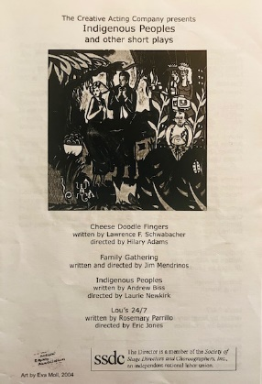
1999
Lou’s 24/7 / Staged Reading
New Jersey Playwrights Festival of New Plays
12 Miles West Theatre, Montclair, N.J.
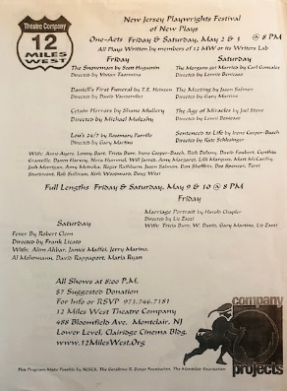
1995
The Waiting Room / Staged Reading
Livewires / New Works by Contemporary New Jersey Writers
Foundation Theatre
Pemberton, N.J.
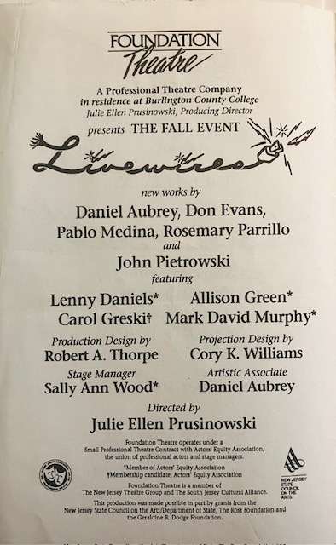
1989
Shelter / Production
New African Grove Company
The Africamericas Festival
Freedom Theatre, Philadelphia, Pa
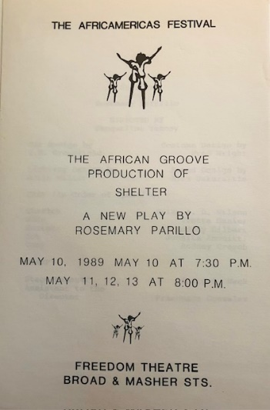.
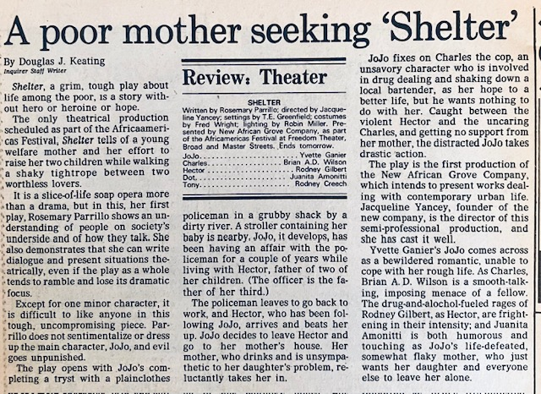
Philadelphia Inquirer review of “Shelter” at Freedom Theater in Philadelphia.

Cent’Anni / Playwriting Showcase
Walnut Street Theatre School
Philadelphia, Pa.
Shelter / Staged Reading
Theater Center
Philadelphia, Pa.
1988
Shelter / Playwriting Lab
Walnut Street Theatre School
Philadelphia, Pa.
1985
Madonna’s Stash / Showcase
Walnut Street Theatre School
Philadelphia, Pa

